|  |  |
| --- | --- |
|  | LAB 3: Analyzing congestion policy, RTT of TCP using NetSim and wireshark. |
|  |  |
|  | Akshar Panchani ID- 202101522  IT304 Computer Networks  8/29/23 |



**Exercise:**

**1.2:**

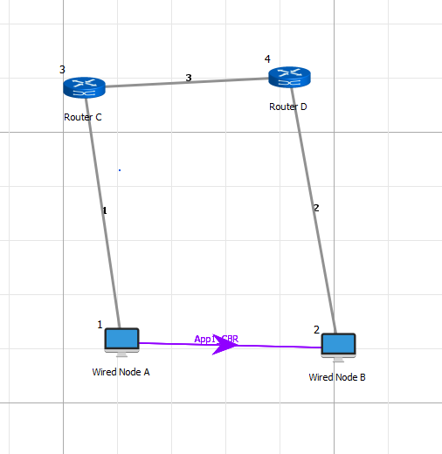

Tahoe:

The slope and the slow start is show by red and blue lines.

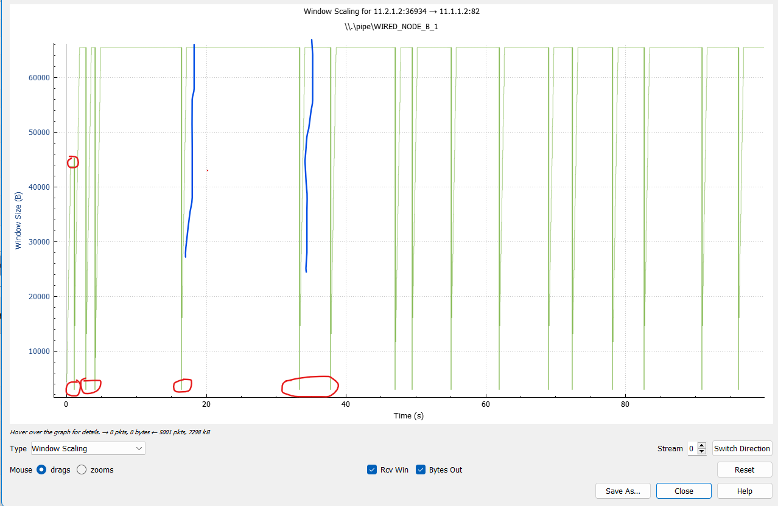

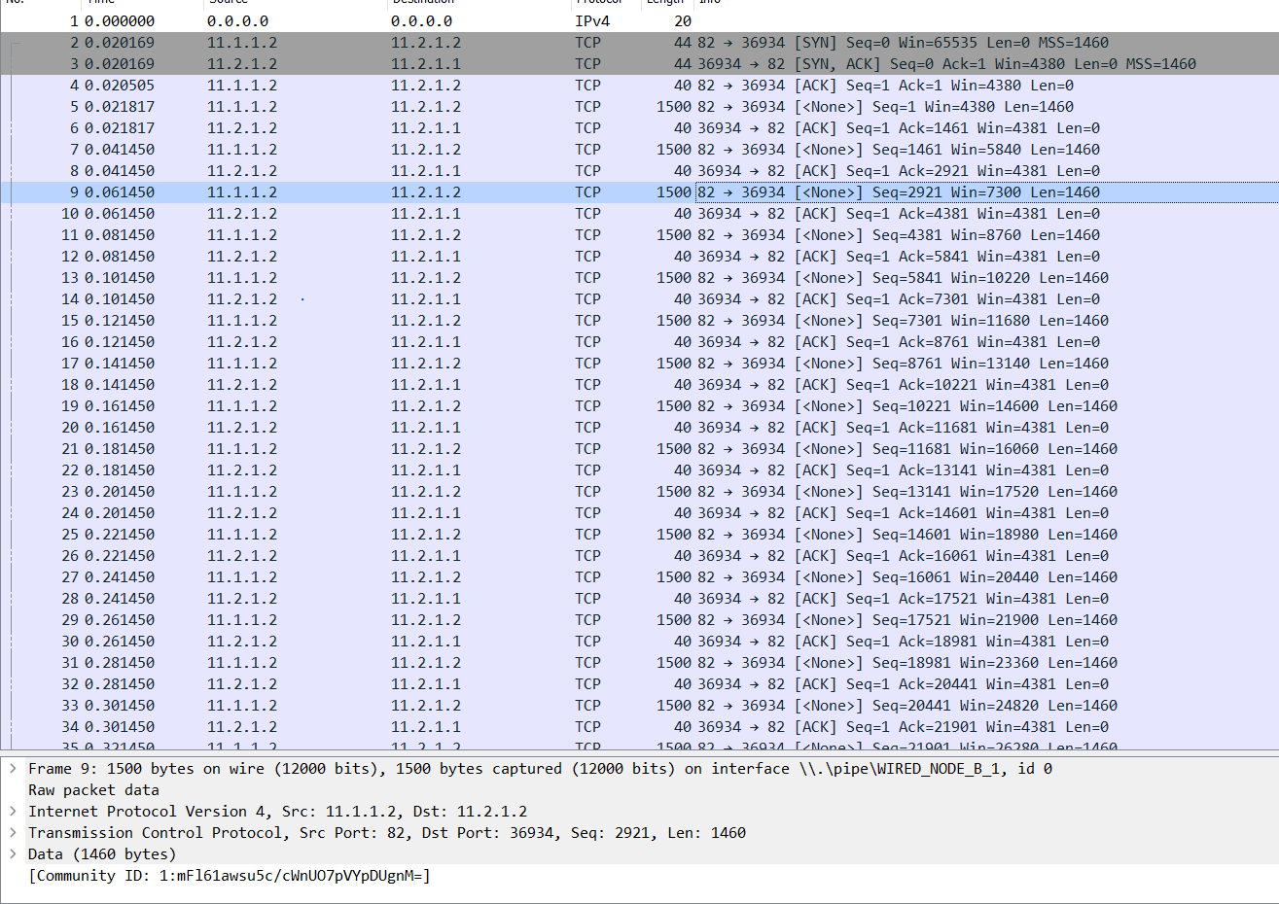

Reno:

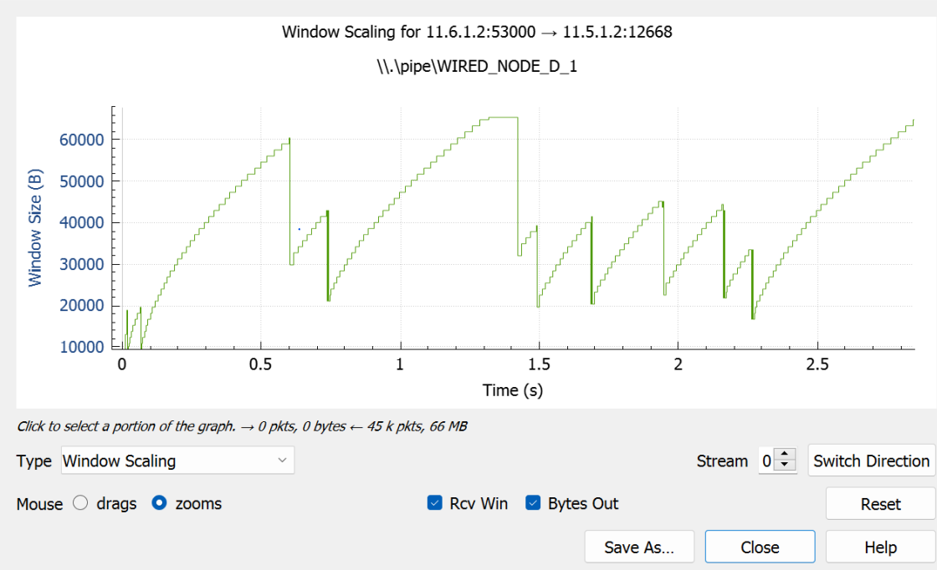

Here the slow start clearly seen and the slope also

1. For both the variant, analyze graph of congestion window, answer the following by marking in the graph.

This all is present in the screenshot attached here, below is the thorough output observed from the points that we have on the graph.

(a) Identify the event of TCP slow start.

Tahoe: 0 - 0.048 sec

Reno: 0.01 - 0.06 sec

(b) Identify the event of packet loss and time out.

Tahoe: ([0.762 - 0.789][ 2.556 - 2.688][ 2.928 - 2.9629],[ 3.142 - 3.165]) sec

Reno: ([0.615 - 0.626],[ 0.740 - 0.761],[ 1.439 - 1.465],[ 1.697 - 1.798],

[2.263 - 2.274 ])sec

(c) Identify the intervals of time when TCP congestion avoidance is operating.

Tahoe: ([0.892 - 2.749],[ 2.786 - 2.927],[ 2.956 - 3.143],[ 3.193 - 3.757]) sec

Reno: ([0.085 - 0.600], [0.852 - 1.454], [1.467 - 1.772], [1.799 - 1.950]) sec

2. What is the difference in congestion control policy of Tahoe and Reno, with respect to congestion avoidance and two events of congestion avoidance phase. Explain briefly in your log book.

In both Tahoe and Reno there is timeout and packet-loss but the difference noticed is that the packet loss in Tahoe is a slow start while in the Reno it starts from the threshold itself to avoid congestion.

**2.1:**

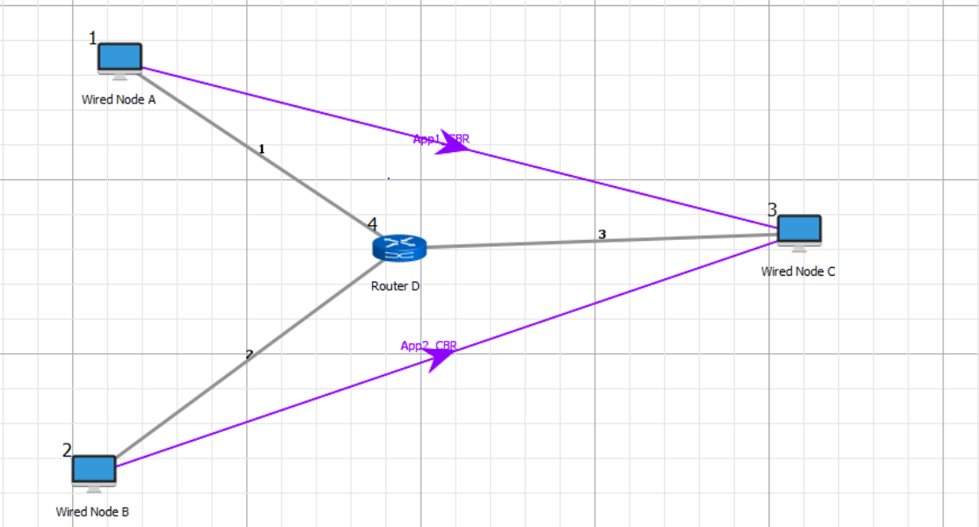

1.Take 3 wired nodes and one router, configure 2 identical CBR applications with default app specification between them as shown in the figure4. And check throughput for both the applications and write down your observation.

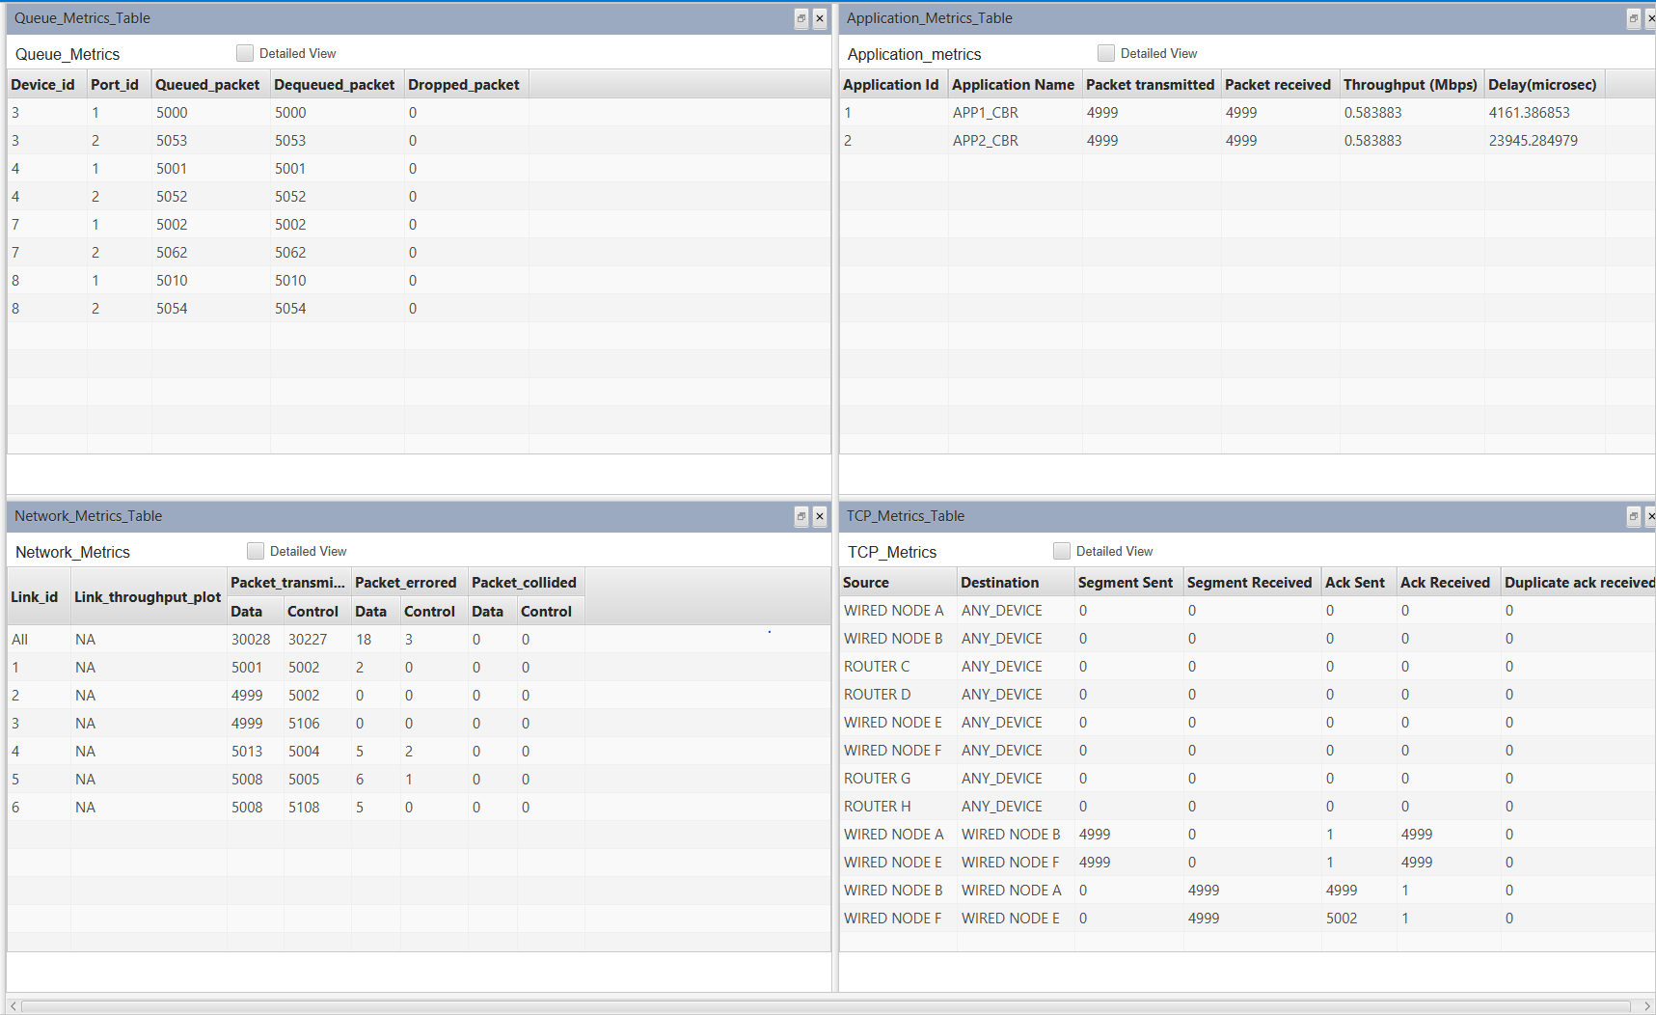

The Output obtain that is the Throughput obtain is 0.583883 Mbps for both the application 1 and 2.

**3.2**

1. Consider the TCP segment containing the HTTP POST as the first segment in the TCP connection. What are the sequence numbers of the first six segments in the TCP connection (including the segment containing the HTTP POST)? At what time was each segment sent? When was the ACK for each segment received? Given the difference between when each TCP segment was sent, and when its acknowledgement was received, what is the RTT value for each of the six segments? What is the EstimatedRTT value after the receipt of each ACK?

Seq no of 1st segment: 1

Sending Time: 0.0364

Ack Time: 0.0634

RTT: 0.0284

Expected RTT time: 0.0284

Seq no of 2nd segment: 2026

Sending Time: 0.0568

Ack Time: 0.0831

RTT: 0.0302

Expected RTT time: 0.0296

Seq no of 3rd segment: 3486

Sending Time: 0.1264

Ack Time: 0.1534

RTT: 0.0771

Expected RTT time: 0.0329

Seq no of 4th segment: 4946

Sending Time: 0.1364

Ack Time: 0.1783

RTT: 0.1152

Expected RTT time: 0.0535

Seq no of 5th segment: 6406

Sending Time: 0.0952

Ack Time: 0.1941

RTT: 0.1389

Expected RTT time 0.0558

Seq no of 6th segment: 7866

Sending Time: 0.0974

Ack Time: 0.2025

RTT: 0.1897

Expected RTT time: 0.0725

2. What is the length of each of the first six TCP segments?

The length of 1st segment: 686

The length of 2nd segment: 1460

The length of 3rd segment: 1460

The length of 4th segment: 1460

The length of 5th segment: 1460

The length of 6th segment: 1460Which after the first is same.

3. What is the minimum amount of available buffer space advertised at the received for the entire trace? Does the lack of receiver buffer space ever throttle the sender?

Minimum window size (Buffer Space) is 5840 bytes. Whereas it can be maximum upto 65535 bytes. Approx. 64kb.

Maximum Segment size: 1460 bytes.

4. Are there any retransmitted segments in the trace file? What did you check for (in the trace) in order to answer this question?

No retransmitted signal is found with any such label.

5. How much data does the receiver typically acknowledge in an ACK? Can you identify cases where the receiver is ACKing every other received segment.

In segment the data is acknowledge of 1460 bytes is acknowledge in ACK. Yes

receiver is ACKing every other segment.

6. What is the throughput (bytes transferred per unit time) for the TCP connection? Explain how you calculated this value.

Throughput = Bytes Transferred/Total Time

161466/5.1s = 31.66 kbps approx..